1. What are the key components D.R.Y?

Don't Repeat Yourself, Reduce the amount of code in an app., Make the code less error prone, and easier to test and maintain.

1. In an ASP.NET Razor application, where is most appropriate to specify the validation rules?

The front in validation

1. DataAnnotations can be applied to both ______ and ________.

Classes or property’s

1. Name two DataAnnotations that were used for validation.

Required and MinimunLength

1. Why does the Price property not have the Required annotation?

[Required] is not used

1. Run the app. Take a screen shot of Create Movie with various validation rules being violated.

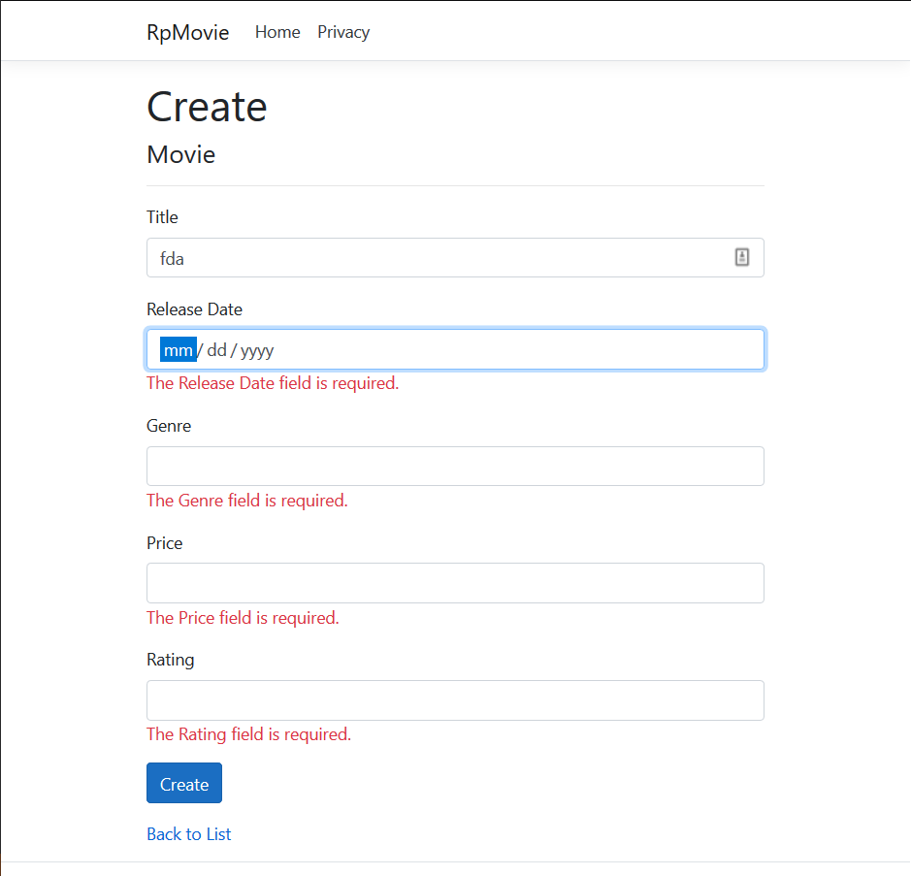

1. What two languages are being used on the client side to enforce any errors?

HTML and C#

1. When does the form data actually get posted to the server?

if (!ModelState.IsValid)

{

return Page();

}

1. What happens if the client browser has Javascript disabled?

The errors will post to the server

1. Use the Validation link to answer the following questions:
   1. What two subsystems represent Model state?

model binding and model validation

* 1. The user entering 56.78 in an integer field would fall into which of the above two subsystem types?

Model binding

* 1. The user entering A when valid values are X, Y or Z would fall into which of the above two subsystem types?

Modle Binding

* 1. What "flag" should be inspected to determine if any model errors are present?
  2. What attribute is an option to using the "flag" from the prior question?
  3. Even though validation is automatic and handled by the controller, what method can be used to rerun validation programmatically?

IClientModelValidator

1. What is the purpose of the attribute [Column(TypeName = "decimal(18, 2)")] for the Price property?

The price has to be two digits or more

1. NOTE: To end this tutorial, the author states that DataAnnotation changes to the model results in changes to the schema, but will not cause Entity Framework to throw exceptions even though the schema is now out of sync with the database structure. But for good measure, it is recommended to prepare a migration for the changes.
2. Using SSOX, copy and paste the current CREATE TABLE of the Movie table.

CREATE TABLE [dbo].[Movie] (

[ID] INT IDENTITY (1, 1) NOT NULL,

[Title] NVARCHAR (60) NOT NULL,

[ReleaseDate] DATETIME2 (7) NOT NULL,

[Genre] NVARCHAR (30) NOT NULL,

[Price] DECIMAL (18, 2) NOT NULL,

[Rating] NVARCHAR (5) NOT NULL,

CONSTRAINT [PK_Movie] PRIMARY KEY CLUSTERED ([ID] ASC)

);

1. After running a migration, copy and paste the revised CREATE TABLE of the Movie table. Highlight the changes in yellow.

